Documentation DifferentCoat Project
Student Name: Ciaran Lynch 30045422
Project: DifferentCoat – Paint Calculation System

Overview of Project
DifferentCoat is a paint calculation system designed to assist trade professionals and general customers in estimating paint requirements. It imports customer data from a CSV file and calculates paint coverage based on room dimensions or surface area, providing accurate measurements for paint quantity in gallons and litres.
Key Packages & Classes
Customers Handles different customer types (TradeCustomer, GeneralCustomer).
Shapes Defines room shapes for general customers.
Utilities Provides helper methods for data import & calculations.
DataAccess Stores constants (COVERAGE, LITRES, WINDOW, DOOR).
Main Executes the system by processing the data file and performing calculations.
System Execution Flow
- Import customer details CSV file is parsed into Customer objects.
- Differentiate customer type Trade vs. General classification.
- Calculate paint requirements Based on predefined constants and room dimensions.
- Display results Provides total paint required in gallons and litres.

Ensure all methods have relevant comments explaining purpose and logic.
Each class is structured with inline comments to improve clarity. Example below from GeneralCustomer class.

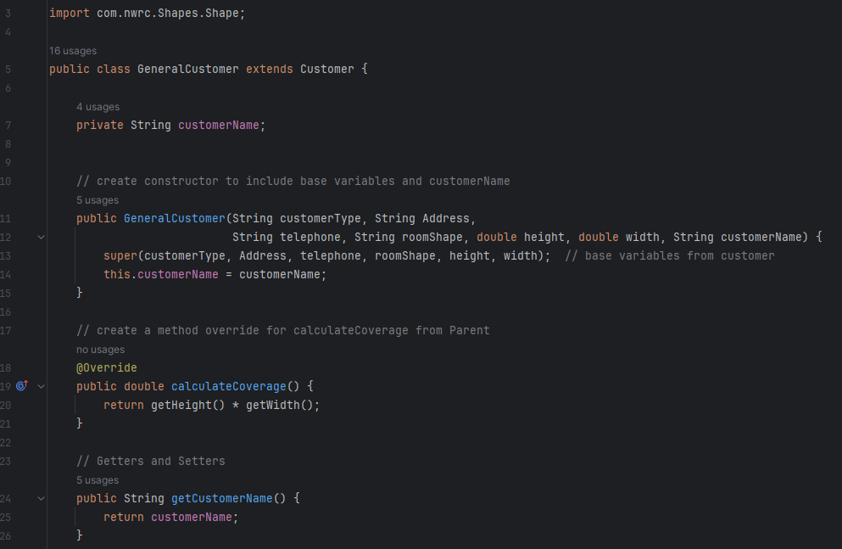
Copy of Original Data File (DataFile.csv)
Attach the original data file ensuring correct formatting.
See below example of CSV File:
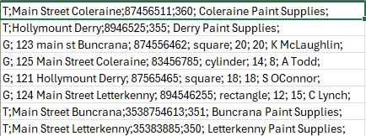

Test Data, Test Cases, Expected vs. Actual Results
The TestNG suite has successfully validated:
Object initialization tests Ensured correct values were set for customers.
Trade Customer tests Ensures Trade customers are set based on the constructor set and paint calculation accuracy.
General Customer tests Ensure General Customer Tests are set based on room shapes, from the constructor set and paint calculation accuracy.
Constants tests Ensure the constant values are correct set.
Imported Customer Tests Ensure CSV File is correctly imported.
See below, TestNg.xml results:

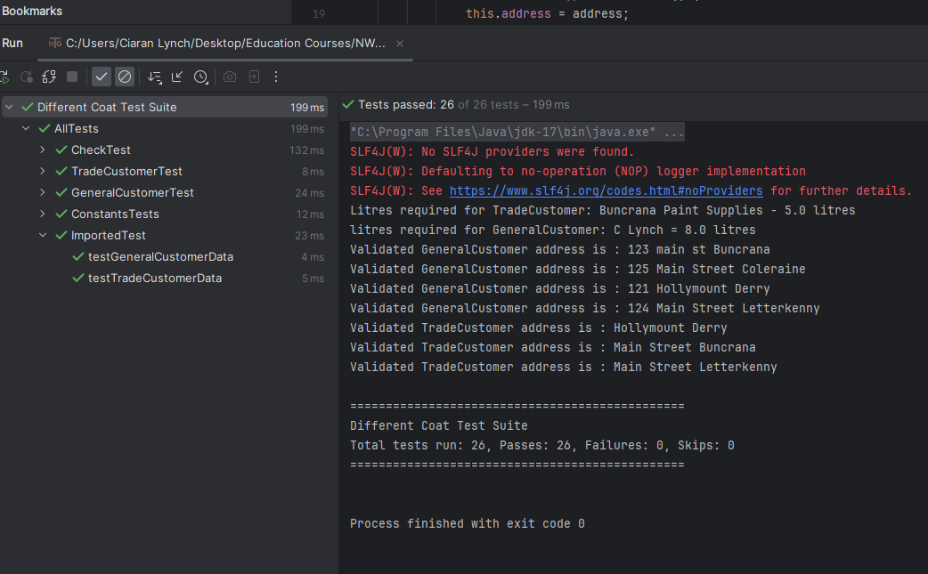

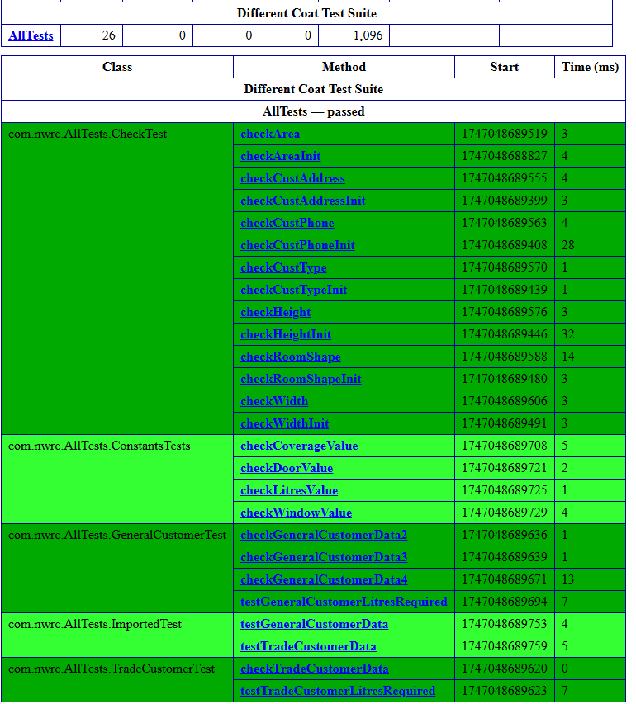

Self-Evaluation Summary
In reflecting on the development of DifferentCoat, key strengths and challenges emerged:
Strengths of the project
- Correct functionality was set up to ensure paint calculations were accurate across different customer types.
- Modular architecture design ensured scalability for future enhancements.
- Automated testing allowed me to validate core features efficiently using TestNG.
Challenges of the project
- Initial setup complexity with importing CSV file as earlier versions of the helper file failed.
- TestNG setup and integration required additional debugging. Refinements were required for error outputs, to produce clearer console messages.
- Formatting console outputs. Refinements may be needed for better readability.

Enhancing System Functionality
- Implement a GUI Interface Introduce a basic user interface for improved accessibility instead of relying solely on console output.
- Improve Logging System Store error messages in an external log file instead of printing them directly to the console, making debugging easier.
- Expand Unit Testing Introduce edge case scenarios for testing purposes, such as extreme surface area values, missing fields, and invalid input types. This can ensure calculations remain accurate without producing invalid results, when dealing with large surface areas. Entering customer data with missing values can confirm error handling works, preventing the system from processing incomplete data and validation catch incorrect formats.
- Create a Configuration File for Constants Instead of hardcoding values (COVERAGE, LITRES), store them in a properties file for easy updates without modifying source code.

Peer Evaluation Summary
After collecting feedback from two peers, here are the key observations:

General Feedback
The program executed correctly, producing accurate paint calculations.
Console output was clear, though slight formatting improvements were suggested.

Code Structure & Maintainability
Modular package structure was praised.
Additional comments in helper methods would improve maintainability.

Error Handling & Testing
Peer 1 recommended ****
Peer 2 recommended ****

Actionable Recommendations
- Enhance CSV import validation to prevent incorrect data entry.
- Improve console output formatting for better readability.
- Expand testing coverage to include more edge case scenarios such as extreme scenarios for room dimensions.

Future Software Maintenance Guidelines
To keep DifferentCoat scalable and efficient, future updates should focus on:
- Improved Error Handling Strengthen validation for missing or incorrect data inputs.
- GUI Integration Implement a JavaFX or web-based interface to improve usability.
- Optimized Test Coverage Expand edge case validation for extreme room sizes.
- Real-Time Paint Pricing API Integrate live cost estimates for users to calculate costs dynamically.

